

Semester One Examination, 2019

Question/Answer booklet

MATHEMATICS

SOLUTIONS
APPLICATIONS
UNIT 1

Section Two:

Calculator-assumed

Student number: In figures

In words

Your name

Time allowed for this section
Reading time before commencing work: ten minutes
Working time: one hundred minutes

Materials required/recommended for this section
To be provided by the supervisor
This Question/Answer booklet
Formula sheet (retained from Section One)

To be provided by the candidate
Standard items: pens (blue/black preferred), pencils (including coloured), sharpener,
correction fluid/tape, eraser, ruler, highlighters

Special items: drawing instruments, templates, notes on two unfolded sheets of A4 paper, and up to three calculators approved for use in this examination

Important note to candidates
No other items may be taken into the examination room. It is your responsibility to ensure that you do not have any unauthorised material. If you have any unauthorised material with you, hand it to the supervisor before reading any further.

Structure of this paper

Section | Number of questions available | Number of questions to be answered | Working  time (minutes) | Marks available | Percentage of examination
Section One:  Calculator-free | 8 | 8 | 50 | 52 | 35
Section Two:  Calculator-assumed | 13 | 13 | 100 | 98 | 65
 |  |  |  | Total | 100

Instructions to candidates

1. The rules for the conduct of examinations are detailed in the school handbook. Sitting this examination implies that you agree to abide by these rules.

2. Write your answers in this Question/Answer booklet preferably using a blue/black pen.
Do not use erasable or gel pens.

3. You must be careful to confine your answer to the specific question asked and to follow any instructions that are specified to a particular question.

4. Show all your working clearly. Your working should be in sufficient detail to allow your answers to be checked readily and for marks to be awarded for reasoning. Incorrect answers given without supporting reasoning cannot be allocated any marks. For any question or part question worth more than two marks, valid working or justification is required to receive full marks. If you repeat any question, ensure that you cancel the answer you do not wish to have marked.

5. It is recommended that you do not use pencil, except in diagrams.

6. Supplementary pages for planning/continuing your answers to questions are provided at the end of this Question/Answer booklet. If you use these pages to continue an answer, indicate at the original answer where the answer is continued, i.e. give the page number.

7. The Formula sheet is not to be handed in with your Question/Answer booklet.
Section Two: Calculator-assumed 65% (98 Marks)
This section has thirteen (13) questions. Answer all questions. Write your answers in the spaces provided.

Working time: 100 minutes.

Question 9 (5 marks)
A sector of a circle of radius $40$ cm is shown below.

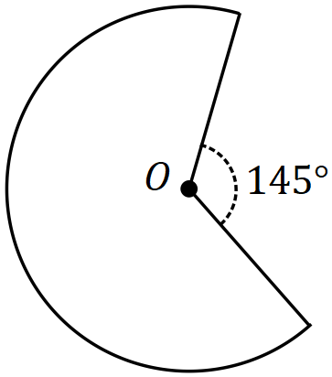

(a) Show that the perimeter of the sector is $230$ cm, when rounded to the nearest cm.
(3 marks)
Solution
Interior angle: $360-145=215°$

Arc length: $L=2π\left(40\right)×\frac{215}{360}=150$

Perimeter: $P=150+40+40=230$ cm

Specific behaviours
interior angle
✓ arc length
✓ total perimeter

(b) Determine the area of the sector. (2 marks)
Solution
Area: $A=π{\left(40\right)}^{2}×\frac{215}{360}$

$A=5027×\frac{215}{360}≈3 000$ cm²

Specific behaviours
area of circle
✓ area of sector

Question 10 (7 marks)
(a) Calculate the value of $f$ given that $f=\begin{matrix}1 \\ \overline{d}\end{matrix}$ and $d=\begin{matrix}1 \\ \overline{d_{1}}\end{matrix}+\begin{matrix}1 \\ \overline{d_{2}}\end{matrix}$ when $d_{1}=0.52$ and $d_{2}=2.86$.
(2 marks)
Solution
$$d=\frac{1}{0.52}+\frac{1}{2.86}=\frac{25}{11}=2.\overline{27}$$

$$f=1÷\frac{25}{11}=0.44$$

Specific behaviours
correct value of $d$
✓ correct answer

(b) The future value, $F$, of an annuity can be calculated using the formula below.

$$F=\frac{C}{r}\left({\left(1+\frac{r}{n}\right)}^{nt}-1\right)$$

Consider an annuity with values $C=\$2 500, r=0.035, n=4$ and $t=5$.

(i) Calculate the future value, rounding your answer to the nearest dollar. (3 marks)
Solution
$$F=\frac{2500}{0.035}\left({\left(1+\frac{0.035}{4}\right)}^{4×5}-1\right)$$

$$F=13595.70$$

$$F≈\$13 596 \text{(nearest \$)}$$

Specific behaviours
evidence of correct substitution
✓ calculates $F$
✓ value to nearest dollar

(ii) Calculate the change in $F$ when the value of $n$ is changed from $4$ to $12$. (2 marks)
Solution
$$F≈\$13 639 \text{(nearest \$)}$$

Increase of $13 639-13 596=\$43$

Specific behaviours
✓ calculates $F$
✓ correct increase

Question 11 (8 marks)
(a) A triangle has sides of length $72$ cm,$97$ cm and $65$ cm. State, with reasons, whether the triangle is right-angled. (2 marks)
Solution
$${65}^{2}+{72}^{2}=9409={97}^{2}$$

Hence triangle is right-angled as the side lengths satisfy Pythagoras' theorem.

Specific behaviours
shows use of $a^{2}+b^{2}=c^{2}$
✓ explanation (must use bolded words)

(b) A $2.5$ m long ladder leans against a $1.8$ m tall wall with the foot of the ladder $0.8$ m away from the base of the wall on level ground.

(i) Draw a two-dimensional sketch of this situation, showing the ladder extending beyond the top of the wall. (2 marks)
Solution
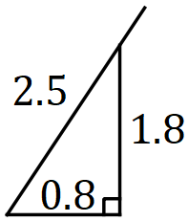

Specific behaviours
sketch with right-angle
✓ includes lengths

(ii) Calculate the distance the ladder extends beyond the top of the wall. (2 marks)
Solution
$$\sqrt{{0.8}^{2}+{1.8}^{2}}=1.97$$

$$2.5-1.97=0.53 \text{m}$$

Specific behaviours
length touching wall
✓ distance extended

(iii) The foot of the ladder is moved along the ground and away from the base of the wall until the top of the ladder is just touching the top of the wall. Determine how far the foot of the ladder was moved. (2 marks)
Solution
Distance from bottom of wall: $\sqrt{{2.5}^{2}-{1.8}^{2}}=1.735$

Moved $1.735-0.8=0.935 \text{m}$

Specific behaviours
distance from wall
✓ distance moved

Question 12 (6 marks)
A researcher at a weather station uses the following formula to calculate $A$, the absolute humidity of the air, where$H$ is the relative humidity and $T$ is the air temperature.

$$A=\frac{12.7×H×{\left(1.07\right)}^{T}}{T+273}$$

(a) Calculate $A$ when $H=55$ and $T=30$. (2 marks)
Solution
$$A=\frac{12.7×55×{\left(1.07\right)}^{30}}{30+273} \\ =17.55$$

Specific behaviours
substitutes correctly
✓ correct value

The formula for $A$ was used to create the spreadsheet below for various values of $H$ and $T$.

$$A$$ |  | $$H$$
 |  | $$40$$ | $$50$$ | $$60$$ | $$70$$ | $$80$$
$$T$$ | $$-10$$ | $$0.98$$ | $$1.23$$ | $$1.47$$ | $$1.72$$ | $$P$$
 | $$0$$ | $$1.86$$ | $$2.33$$ | $$2.79$$ | $$3.75$$ | $$3.72$$
 | $$10$$ | $$3.53$$ | $$4.41$$ | $$5.30$$ | $$6.18$$ | $$7.06$$
 | $$20$$ | $$Q$$ | $$8.39$$ | $$10.06$$ | $$11.74$$ | $$13.42$$

(b) Calculate the value of the entries $P$ and $Q$ shown in the spreadsheet. (2 marks)
Solution
$$P=1.96$$

$$Q=6.71$$

Specific behaviours
value of $P$
✓ value of $Q$

(c) One of the entries in the spreadsheet is incorrect. State the value of $T$ and the value of $H$ for the cell in which the incorrect value lies and calculate the correct value of $A$. (2 marks)
Solution
$$T=0, H=70$$

$$A=3.26$$

Specific behaviours
correct values of $T$ and $H$
✓ correct value of $A$

Question 13 (6 marks)
A bakery sells a specialty cake in the shape of a square-based pyramid. The sides of the square are all $32$ cm and the vertex of the pyramid, $V$, lies $21$ cm directly above the centre of the square base, $C$. The mid-point of one of the sides of the square is $M$.

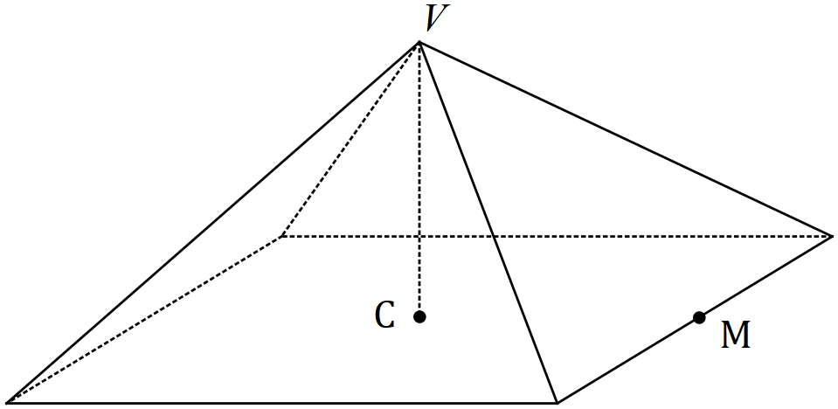

(a) Determine the volume of the cake. (2 marks)
Solution
$$V=\frac{1}{3}\left(32×32\right)×21 \\ =7 168 {\text{cm}}^{2}$$

Specific behaviours
indicates area of base
✓ correct volume

(b) Calculate the length $VM$. (2 marks)
Solution
$$MC=32÷2=16$$

$$VM=\sqrt{{21}^{2}+{16}^{2}} \\ =26.4 \text{cm}$$

Specific behaviours
indicates lengths $MC$ and $VC$
✓ correct distance

(c) The four triangular faces are iced at a cost of $1.4$ cents per square cm. Determine the cost of icing the cake, in dollars and cents. (2 marks)
Solution
$$A=4×\frac{1}{2}×32×26.4 \\ =1689.6$$

$$C=1689.6×0.014 \\ =\$23.65$$

Specific behaviours
correct TSA
✓ correct cost

Question 14 (9 marks)
The weekly sales of Sumsang phones (the Ten, Plus and Note models) at retail outlets $A$, $B$ and $C$ is shown in matrix $M$.

$$\begin{matrix} & \begin{matrix}A & B & C\end{matrix} & \\ M= & \left[\begin{matrix}60 & 25 & 36 \\ 42 & 32 & 28 \\ 55 & 30 & 34\end{matrix}\right] & \begin{matrix}Ten \\ Plus \\ Note\end{matrix}\end{matrix}$$

(a) In total, how many Note models were sold? (1 mark)
Solution
$$55+30+34=119$$

Specific behaviours
correct number

(b) What does the element $m_{21}$ in matrix $M$ represent? (1 mark)
Solution
The number of Plus models sold by store A

Specific behaviours
mentions store and model

(c) Determine the matrix $Q$, where $Q=\left[\begin{matrix}1 & 1 & 1\end{matrix}\right]×M$, and explain what $Q$ shows. (2 marks)
Solution
$$Q=\left[\begin{matrix}157 & 87 & 98\end{matrix}\right]$$

The total number of phones sold at each of the stores during the week.

Specific behaviours
correct $Q$
✓ correct explanation

(d) Determine the matrix $N$, where $N=M×\left[\begin{matrix}1 \\ 1 \\ 1\end{matrix}\right]$, and explain what $N$ shows. (2 marks)
Solution
$$N=\left[\begin{matrix}121 \\ 102 \\ 119\end{matrix}\right]$$

The total number of each model sold during the week.

Specific behaviours
correct $N$
✓ correct explanation

(e) The Ten, Plus and Note models are sold for $\$899$, $\$949$ and $\$1 149$ respectively.

(i) Use this information to write matrix $P$ that can be multiplied by matrix $N$ to yield a sensible result. (1 mark)
Solution
$$P=\left[\begin{matrix}899 & 949 & 1149\end{matrix}\right]$$

Specific behaviours
correct matrix

(ii) Multiply matrices $P$ and $N$ together and explain what the result shows. (2 marks)
Solution
$$P×N=\left[342308\right]$$

The total sales income from selling all the phones at all the stores.

Specific behaviours
correct product, as matrix
✓ correct explanation

Question 15 (7 marks)
A shop sold three sizes of the same brand of soy sauce. The $225$ mL bottle cost $\$2.70$, the $375$ mL bottle cost $\$4.35$ and the $660$ mL bottle cost $\$8.25$.

Retail laws require the shop to display the price per $100$ mL for each bottle, to the nearest cent.

(a) Calculate the price per $100$ mL for all three sizes of soy sauce. (3 marks)

Solution
$$225: 270÷225×100=120 \text{c}$$

$$375: 435÷375×100=116 \text{c}$$

$$660: 825÷660×100=125 \text{c}$$

Specific behaviours
uses unit cost for one size
✓ correct 100 mL price for one size
✓ all three prices correct

(b) Use the unit prices to list the bottle sizes in order of value, from best to worst. (1 mark)
Solution
$$375 \text{mL}, 225 \text{mL}, 660 \text{mL}$$

Specific behaviours
correct order

(c) Determine the maximum price, to the nearest cent, for a $525$ mL bottle of the same sauce if the shop wanted it to be better value than the other three sizes in terms of unit price.
(2 marks)
Solution
$$525÷100×116=609 \text{c}$$

To be best value, price must be less, so $\$6.08$.

Specific behaviours
calculates price to be equal best
✓ correct price

(d) Suggest one reason that a shopper may prefer a size other than that which offers the best value in terms of unit price. (1 mark)
Solution
- avoid wastage
- don't have enough money, etc, etc
Specific behaviours
sensible reason

Question 16 (6 marks)
A wood turner crafted solid shape $S$ as shown below - a hemisphere of radius $15$ cm atop a cylinder with the same radius and height $18$ cm.

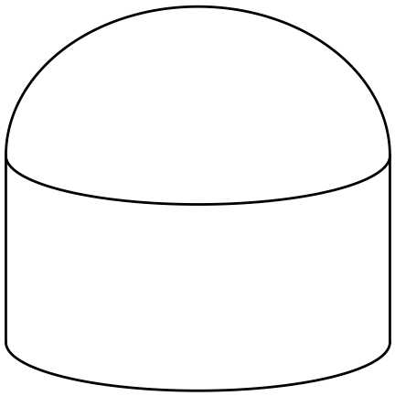

(a) The wood turner started out with a block of wood in the shape of a rectangular prism with dimensions $40×35×35$ cm. Determine the volume of wood that was removed from this block to end up with shape $S$. (3 marks)
Solution
$$V_{CYL}=π{\left(15\right)}^{2}\left(18\right) \\ =12 723$$

$$V_{HS}=\frac{1}{2}×\frac{4}{3}×π{\left(15\right)}^{3} \\ =7 069$$

$$V_{PRISM}=40×35×35=49 000 \\ V_{REMOVED}=49000-12723-7069 \\ =29 208 {\text{cm}}^{3}$$

Specific behaviours
cylinder volume
✓ hemisphere volume
✓ correct volume removed

(b) Shape $S$ was then cut vertically into two congruent halves. Determine the area of one of the cut faces. (3 marks)
Solution
$$A_{SEMICIRCLE}=\frac{1}{2}×π×{15}^{2} \\ =353$$

$$A_{RECTANGLE}=30×18 \\ =540$$

$$A_{CUT}=353+540 \\ =893 {\text{cm}}^{2}$$

Specific behaviours
✓ uses correct cross-sections
semi-circle area
✓ correct total

Question 17 (12 marks)
A spreadsheet to track a monthly car budget is shown below, with all amounts in dollars. The figures for months 1, 2 and 3 show the actual expenditure for each item.

Item | Monthly Budget | Month 1 | Month 2 | Month 3 | 3-Month Total
Loan payment | $$405$$ | $$405$$ | $$405$$ | $$405$$ | $$1215$$
Insurance | $$225$$ | $$225$$ | $$225$$ | $$225$$ | $$R$$
Maintenance | $$108$$ | $$0$$ | $$458$$ | $$45$$ | $$503$$
Fuel | $$162$$ | $$215$$ | $$174$$ | $$Q$$ | $$582$$
Total | $$P$$ | $$845$$ | $$1262$$ | $$858$$ | $$S$$

(a) Determine the values of $P, Q, R$ and $S$ in the spreadsheet. (3 marks)
Solution
$$P=900$$

$$Q=582-\left(215+174\right)=193$$

$$R=3×225=675$$

$$S=2 975$$

Specific behaviours
one correct value
✓ at least 3 correct values
✓ all correct values

(b) A motoring organisation recommends allocating no more than $15\%$ of a person's monthly income to running a car. Would a person on a salary of $\$67 500$ pa and using the total monthly budget figure above meet this target? Justify your answer. (3 marks)
Solution
$$67500÷12=5625$$

$$\text{Target:} 5625×0.15=\$843.75$$

Since the budget total is $\$900$ but the recommended maximum is only $\$843.75$, they do not meet the target.

Specific behaviours
calculates monthly salary
✓ calculates correct percentage
✓ explains why they do not meet target

(c) Over the three months shown, the total actual expenditure for two items exceeded their budgeted figures.

(i) Which items were these? (1 mark)
Solution
Maintenance and fuel

Specific behaviours
correct items

(ii) Determine which of these two items exceeded their budgeted figure by the largest percentage. (3 marks)
Solution
Maintenance: $503-3\left(108\right)=503-324=179$

$$\frac{179}{324}×100=55\%$$

Fuel: $582-3\left(162\right)=582-486=96$

$$\frac{96}{486}×100=20\%$$

Maintenance exceeded by the largest percentage.

Specific behaviours
% figure for maintenance
% figure for fuel
✓ states correct item

(d) The monthly budget figure for insurance includes a $10\%$ tax. Determine the cost of the insurance without this tax. (2 marks)
Solution
$$225÷1.10=\$204.55$$

Specific behaviours
indicates appropriate method
✓ correct cost, to nearest cent

Question 18 (8 marks)
Single people aged between $18$ and $21$, living at home and looking for work qualify for the youth allowance of $\$304.40$ per fortnight, unless they earn more than $\$668.17$ in that time, in which case no allowance is paid.

In any fortnight that they earn between $\$143$ and $\$250$, the allowance will be reduced by $50$ cents in the dollar for earnings over $\$143$.

In any fortnight that they earn between $\$250$ and $\$668.17$, the allowance will be reduced by $\$53.50$ plus $60$ cents in the dollar for earnings over $\$250$.

Determine, with justification, the fortnightly youth allowance paid to each of the following.

(a) Alex, who earns $\$66$ per week. (2 marks)
Solution
$$66×2=\$132$$

Full allowance of $\$304.40$

Specific behaviours
indicates fortnightly earnings
✓ correct allowance

(b) Bay, who has a part time job paying $\$15.25$ per hour for $12$ hours each fortnight. (3 marks)
Solution
$$15.25×12=\$183$$

Will lose $(183-143)×0.5=\$20$

Allowance of $304.40-20=\$284.40$

Specific behaviours
indicates fortnightly earnings
✓ indicates correct deduction
✓ correct allowance

(c) Cara, who is paid $\$16.40$ per hour for working $6$ hours a day for $3$ days a week.
(3 marks)
Solution
$$16.40×6×3×2=\$590.40$$

Will lose $(590.40-250)×0.6=204.24$

Allowance of $304.40-53.50-204.24=\$46.66$

Specific behaviours
indicates fortnightly earnings
✓ indicates correct deduction
✓ correct allowance

Question 19 (8 marks)
A right-triangular prism has dimensions shown in the diagram below.

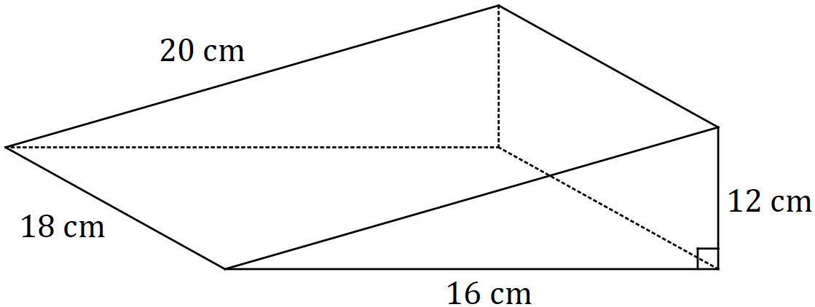

(a) Determine the total surface area of the prism. (3 marks)
Solution
Triangular ends: $2×\frac{1}{2}×16×12=192$
Rectangles: $18×\left(12+16+20\right)=864$

TSA: $192+864=1 056$ cm²

Specific behaviours
indicates area of triangle
✓ indicates area of rectangle
✓ correct TSA

(b) An eighth-size model is made of the prism, i.e. using a scale of $1:8$. Calculate the total surface area of this model. (2 marks)
Solution
Area scale factor: ${\left(\frac{1}{8}\right)}^{2}=\frac{1}{64}$
Area: $1056×\frac{1}{64}=16.5$ cm²

Specific behaviours
indicates area scale factor
✓ correct area

(c) Determine the volume of the original prism. (1 mark)
Solution
Volume: $\frac{1}{2}×16×12×18=1 728$ cm³

Specific behaviours
correct volume

(d) Another scale model is made of the prism, so that the dimensions of the sloping face are now $3.6$ cm by $4$ cm. Calculate the volume of this scale model. (2 marks)
Solution
Scale factor: $\frac{4}{20}=\frac{1}{5}$. Volume sf ${\left(\frac{1}{5}\right)}^{3}=\frac{1}{125}$

Volume: $1728×\frac{1}{125}=13.824$ cm³

Specific behaviours
indicates scale factor for length and volume
✓ correct volume

Question 20 (8 marks)
(a) An investor pays $\$57 250$ into a new account offering interest of $2.85\%$ pa, with interest payable every $90$ days. The investor closes the account and withdraws the principal and interest just after the first interest payment.

Calculate the amount they withdraw. (3 marks)
Solution
$$I=57250×0.0285×90÷365 \\ =402.32$$

$$57250+402.32=\$57 652.32$$

Specific behaviours
correctly substitutes
✓ calculates interest
✓ correct withdrawal

(b) Another person invested $\$4 000$ with a bank that offered an interest rate of $5.2\%$ pa.

(i) Determine the value of the investment after two years when interest is compounded annually. (2 marks)
Solution
$$A=4000{\left(1+0.052\right)}^{2} \\ =\$4 426.82$$

Specific behaviours
correctly substitutes
✓ correct value

(ii) The person was advised that they would be better off after two years if they invested the same sum with another bank that was offering an interest rate of $5.1\%$ pa compounded monthly. State, with justification, whether this was good advice.
(3 marks)
Solution
$$A=4000{\left(1+\frac{0.051}{12}\right)}^{2×12} \\ =\$4 428.58$$

Advice was good - they were $\$1.76$ better off.

Specific behaviours
correctly substitutes
✓ correct value
correct conclusion

Question 21 (8 marks)
The washer shown below is made of plastic and has an internal radius of $9$ mm, an external radius of $23$ mm and is $4$ mm thick.

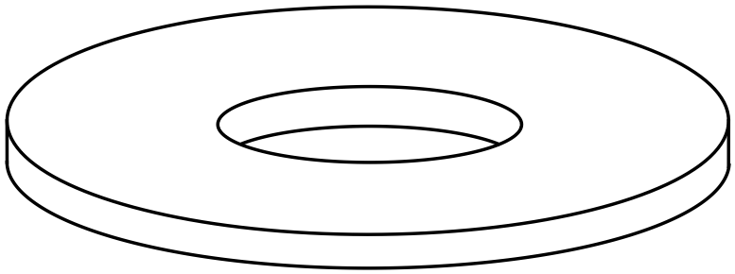

(a) The plastic used to make the washers costs $75$ cents per litre. Given that one litre is $1 000$ cubic centimetres, determine the cost of making $5 000$ of the washers. (4 marks)
Solution
Outer volume: $π×{2.3}^{2}×0.4=6.648$

Inner volume: $π×{0.9}^{2}×0.4=1.018$

Total volume: $\left(6.648-1.018\right)×5000=5.63×5000=28150$

Cost: $28150÷1000×0.75=\$21.11$

Specific behaviours
outer volume
✓ inner volume
✓ volume of all washers
✓ correct cost

(b) Calculate the total surface area of one washer, giving your answer in mm². (4 marks)
Solution
Outer cylinder: $A_{1}=2π{\left(23\right)}^{2}+2π\left(23\right)\left(4\right)=3902$

Inner circles: $A_{2}=2π{\left(9\right)}^{2}=509$

Inner walls: $A_{3}=2π\left(9\right)\left(4\right)=226$

TSA: $A=3902-509+226=3 619$ mm²

Specific behaviours
outer cylinder
✓ inner circles
✓ inner walls
✓ correct TSA

Supplementary page

Question number: _________

Supplementary page

Question number: _________

© 2019 WA Exam Papers. Kennedy Baptist College has a non-exclusive licence to copy and communicate this document for non-commercial, educational use within the school. No other copying, communication or use is permitted without the express written permission of WA Exam Papers. SN245-133-4.

